# Thermal design for Minotaur Pallet

PJG 23/10/2018

## Key drivers

* Quieter than Matador; this is currently subjective - there is no dB target.
* Mass of pallet should be less than Matador; aim for 1kg reduction, giving target mass of 2.8kg including spreader and fans but excluding PCB.
* Some reduction in thermal performance is allowable to support the above.
* Amplifier is to be rated for 1kW ICAS (Intermittent Commercial and Amateur Service). We interpret this as continuous SSB or CW operation at full power, or key down at 1kW for followed by 5 minutes in standby.[1]
* Target dimensions assuming use of a MS177-32-35 enclosure, 165h x 125w x 225d including PCB and fans.
* Reproducible design that avoids the use of bespoke/exotic parts.

## Design objectives

The Matador pallet uses an open heatsink with the fans positioned about 30mm from the side, thus the airflow is loosely directed over the fins.[2] The aim with Minotaur will be to use a more thermally efficient design, allowing a smaller/lighter heatsink and slower fan speed to reduce acoustic noise. A ‘box’ design in which the fans are directly attached to the heatsink should be able to meet these requirements as all of the airflow is directed over the fins and none is wasted.

The following principles are believed to apply when optimising the design of a heatsink:

* Make the total surface area as large as possible - this implies a heatsink with as many fins with as large an area per fin as possible. The use of a ridged surface will further increase the area.
* Increasing the width/height has a greater effect on the thermal resistance than increasing the length - this is because a larger area is exposed to cool air entering the heatsink. A further issues is that as the length increases, the air temperature eventually ‘saturates’ i.e. the air becomes too hot to extract any more heat from the heatsink.
* Fans can be fitted to the exhaust side of the heatsink to increase air flow. A decavitation chamber between the heatsink and the exhaust fans may improve air flow and reduce acoustic noise.[3]

A Fischer LA 7 heatsink was already available so it was decided to evaluate this as a starting point. The dims of this heatsink are 74h x 125w x 150d. The heatsink is already fitted with a 100 x 100 x 10cm copper spreader and 800W termination for use as a dummy load. The surface area of this heatsink is approximately:

16 surfaces of 15cm x 5.5cm, ridged to give say 25% increase in area = 1650cm2

2 inner ridged surfaces 15cm x (5.5+0.4x22) = 429cm2

2 outer ridged surfaces 15cm x (5.5 +0.2x22) = 297cm2

Total area = 2,376cm2

In SSB mode, we can expect a mean power level of circa 50% of PEP, assuming very heavy speech processing (10-20% of peak with no processing). In CW mode the mean power level will be more like 33%.[4] Measurements on Matador show that an amplifier efficiency of 66% is realistic, so for 1kW PEP, the heatsink must be able to continuously dissipate 1kW x 0.5 x 50% = 250W.

To meet the full power key down requirement, the heatsink must also be able to dissipate 1kW x 0.5 = 500W for a 5 minute key down period followed by 5 minutes rest.

Referring to the BLF188 datasheet, θjc is 0.1K/W and the solder interface to the heatsink might add 0.025K/W, giving 0.125K/W.[5] Therefore the approximate spreader to junction temperature difference is going to be 63K at 500W and 32K at 250W. The maximum allowable device junction temperature is 180C, so allowing a 50% temperature margin, a conservative upper limit for the spreader temperature might be 80C.

To summarise, our aim with the thermal design is to stay under 80C after 5 minutes at 500W dissipation into the heatsink. And at 250W dissipation we will expect the temperature to stay under 80C indefinitely.

## Measurements using PABST 612 NHH fans

The graph below shows the measured temperature near the centre of the spreader using the supplied EBM PABST 612 NHH fans. These produce significant air flow (datasheet 6800RPM / 56m3/hr) and sounded far too noisy to be suitable for this application. However they give an idea of the best thermal performance possible with this heatsink. Testing was carried out for an on period of 3 minutes, but extrapolating the graph it can been seen that after 5 minutes the temperature would be around 56 degrees at 500W and around 45 degrees at 300W.[6]

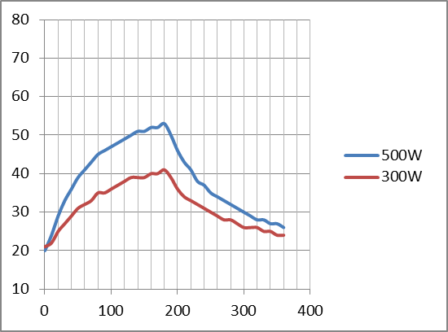

As the ambient temperature for the test was 19C, the temperature rises are 37C and 26C respectively. These correspond to a thermal resistance of 0.074K/W and 0.087K/W, corresponding well with the datasheet value of 0.075K/W.

**From this test we conclude that the supplied PABST fans would support continuous operation key down at 1kW, provided a compromise in the acoustic noise could be accepted. For my purposes quieter operation is the driver, and I don’t need to use digital modes at high power.**

## Noctua NF-A6 fans

For the next test, the PABST fans were replaced with Noctua NF-A6 25mm fans. The acoustic noise spec for these is about 19dB(A), compared with 41dB(A) for the PABST. The speed is slower at 3000 rpm and the airflow 29.2m3/hr.

The Noctua fans were tested at an ambient of 21C. The results suggest a temperature of about 73C would be reached after 5 minutes at 500W, and about 50C after 5 minutes at 300W. The fans are almost silent in operation, the main sound being generated by the air passing through the heatsink.

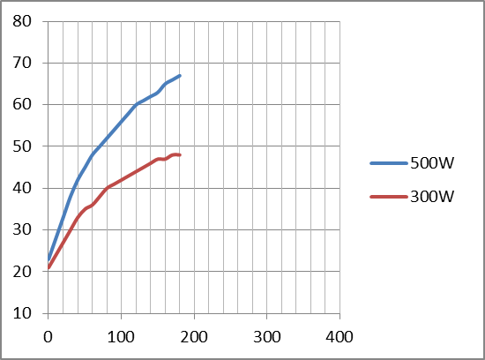

**It looks as if this cooling arrangement will adequate as the spreader temperature won’t exceed 50C during routine SSB/CW operation at full rated output. The spec also calls for the amplifier to be capable of a key down period of 5 minutes at full power, and again this requirement is just met without the heatsink temperature exceeding the magic 80C figure.**

As an additional more representative test the heatsink was tested by transmitting a CW text at 500W PEP for five minutes. The heatsink temperature at the end of the test was a comfortable 42C.

There may be some scope for optimisation by adding exhaust fans and/or using decavitation chambers. This is of interest because it could increase the thermal margin with only minor modifications.

## Adding exhaust fans

Two AAB super silent fan 6 fans were fitted to the exhaust side of the heatsink. A single 10mm decavitation chamber was available in the form of a scrap fan housing, so this was fitted to one exhaust fan. The other exhaust fan had no decavitation chamber.

The results are shown below - this time the PA was run for a full 5 minutes for the test. No anemometer was available to measure any increase in air flow, however the temperature rise in the spreader can be compared with previous results to see if the heatsink performance has improved.

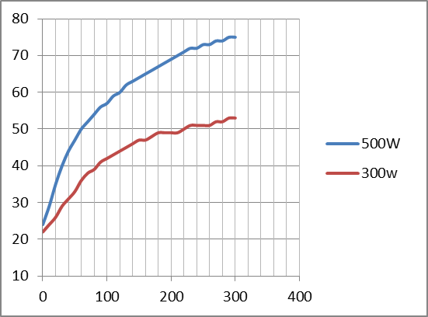

**In fact the temperature profiles for the two power levels and the final temperatures of 75C and 53C are almost identical to the results of the preceding test. This shows that the addition of the exhaust fans makes no practical difference.**

## Increasing supply voltage

The next test was to try the effect of over-driving the fans slightly by increasing the supply voltage from 12V to 14V. For this test there were no exhaust fans fitted. The results for 500W drive power are shown below. **As can be seen the increase in voltage and hence fan speed has no significant effect on the temperature, the difference between the lines being explained by a slightly higher room temperature during the 12V test.**

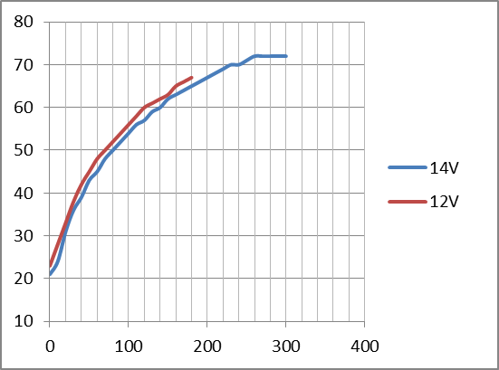

1. [http://www.ab4oj.com/quadra/icas.html](http://www.ab4oj.com/quadra/icas.html%20)
2. 24 fins, 6 in long by 2.25 in high. Total area = 4180cm2
3. See report on the RF-Kit amplifier by 5B4AGN
4. this is the duty cycle if you transmitted the word PARIS continuously
5. thermal conductivity of solder = 50W/mK; thickness 50um, area 41x10mm; R = 50um/(41x10mm)/50 = 0.025K/W
6. 300W is the minimum power level possible with the test setup.